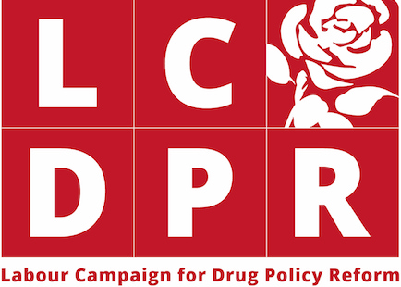

Individual Submission Form

This form is an opportunity for Labour members and voters to have their individual views on drug policy considered by the Campaign’s Expert Working Group.

Name (optional):
Town/city:

1) What do you feel are the key issues with UK drug policy?

2) How would you like the Labour Party’s drug policy to be reformed? Is there any particular policies that you would like the Labour Party to support?

3) Is there anything else that you would like to add to your submission?

4) Please fill in the details below if you would you like to be added to the Campaign’s mailing list.

Name:
Email address:

Optional Demographic Questions

This information will help the Campaign identify if it has engaged with a diverse range of people.

If you do not wish to answer any of the questions, please leave the spaces blank.

1) Town/City of Residence:...............................................................

2) Gender:........................................................................................

3) Age:..............................................................................................

4) Ethnicity:.......................................................................................

O Arab
O Asian or Asian British – Indian
O Asian or Asian British – Pakistani
O Asian or Asian British – Bangladeshi
O Asian or Asian British – any other Asian background
O Black or Black British – Caribbean
O Black or Black British – African
O Black or Black British – any other Black background
O Chinese
O Mixed – White and Black Caribbean
O Mixed – White and Black African
O Mixed – White and Asian
O Mixed – Any other mixed background
O White – British
O White – Irish
O White – any other White background
O Any other ethnic origin group………………………..

